Practical Activity 5

Sally Mukami

[Sally.mukami@womentechsters.org](mailto:Sally.mukami@womentechsters.org)

1. I started by creating three organizational units in my local domain. The name of my domain is Mukami.local. Therefore, I have:

* Headquarters
* Sales1=CarMax east
* Sales2=CarMax west

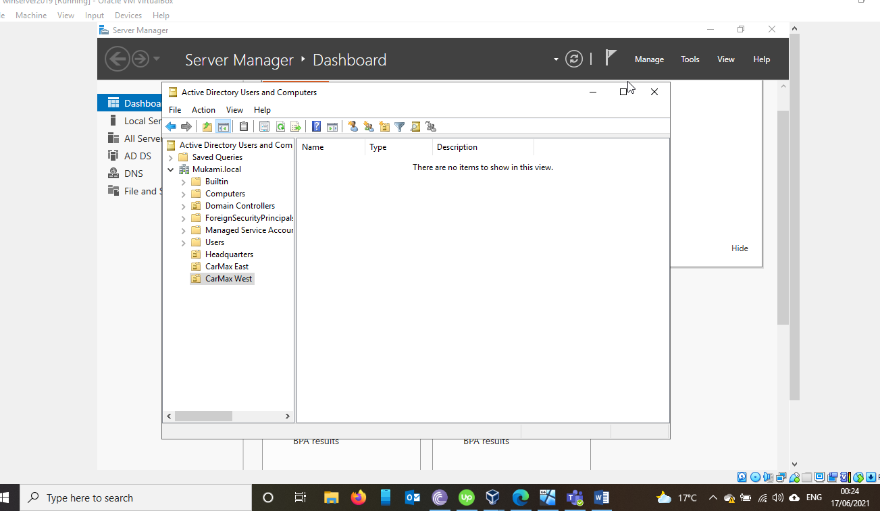

1. I have created the different users for each region in groups as a sub-organizational unit of Headquarters.

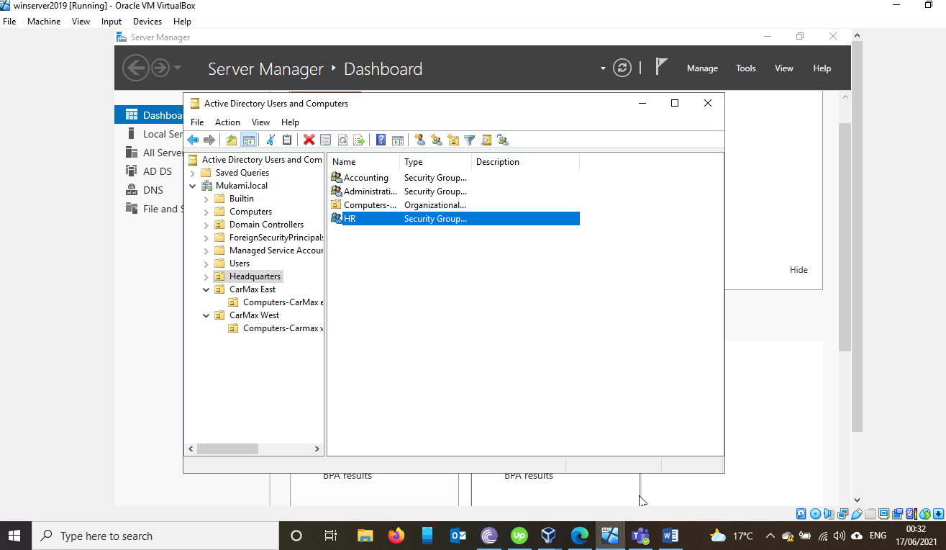

1. For the sales department, the groups cannot have the same name so I labeled them as “…-CarMax east” or “….-CarMax west”

Example Sales-CarMax east

Sales-CarMax west

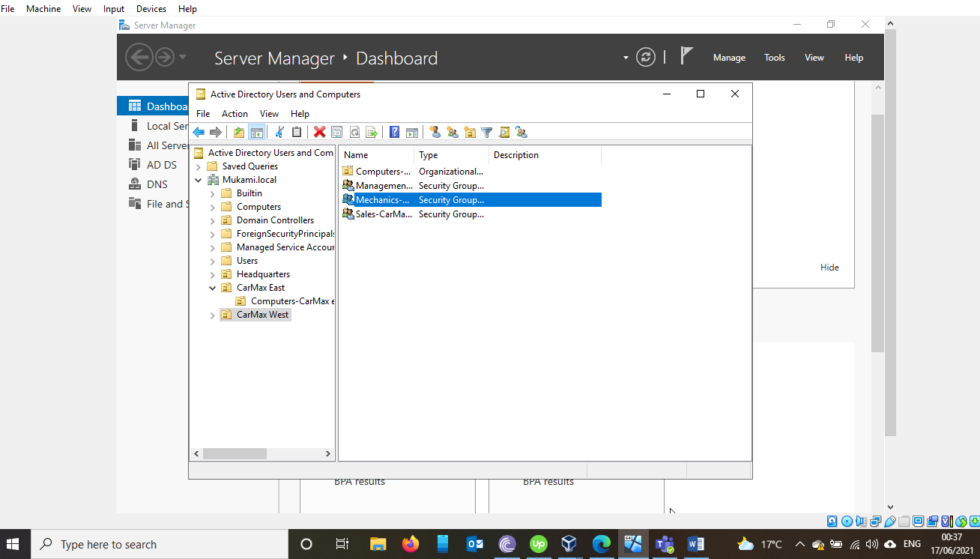

1. The Dummy users under each Unit

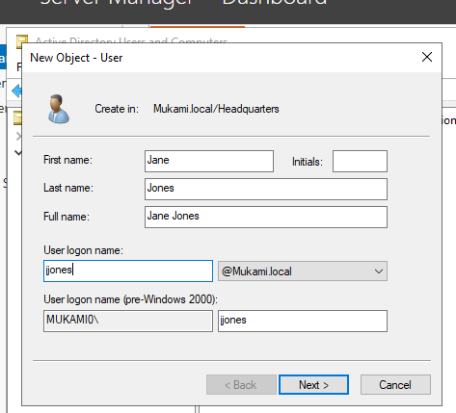

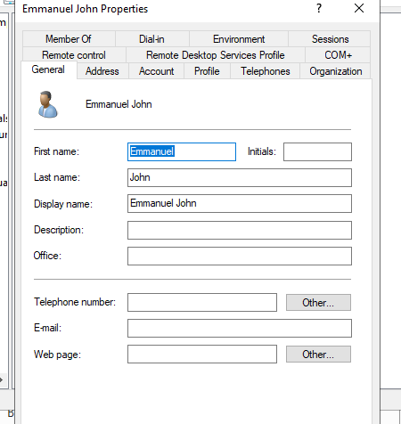

1. how you will handle this and make sure the sales user is effectively transitioned to Administrative Unit.

Answer

My dummy user is called Salinta Kagai and she is in the Sales-CarMax west Unit. To move her to administrative dept, I right click on the user account and select move:

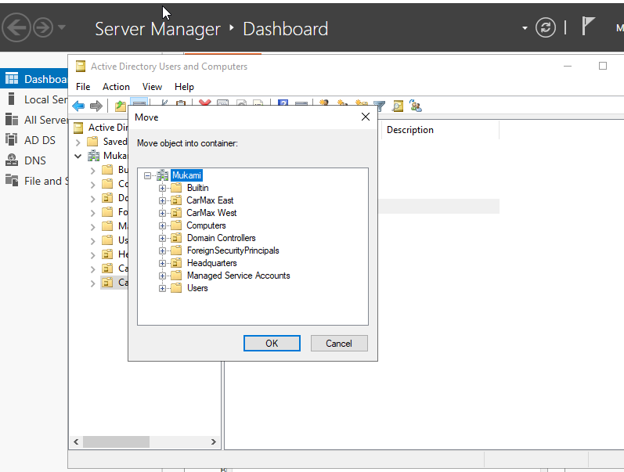

And then selecting the container where I want to move her to, in this case it is the Headquarters. The user account was moved to the Headquarter unit.

Since she was part of the sales group, right click on the profile then **properties** and select **member of,** select the name of the former group and choose **remove.**

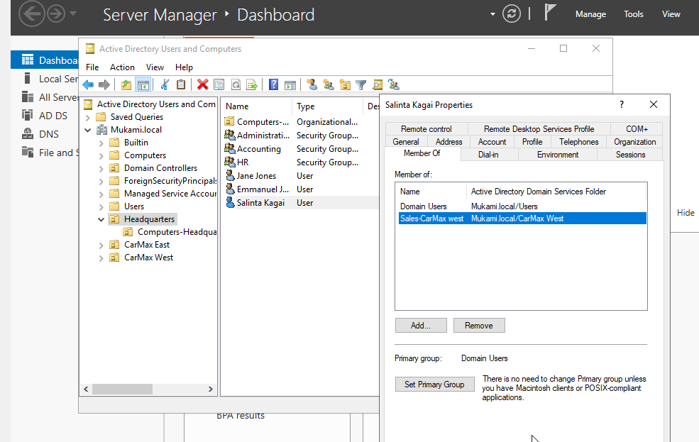

The next step is to select the user account and select **add to group** to Successfully add her to the administrative account

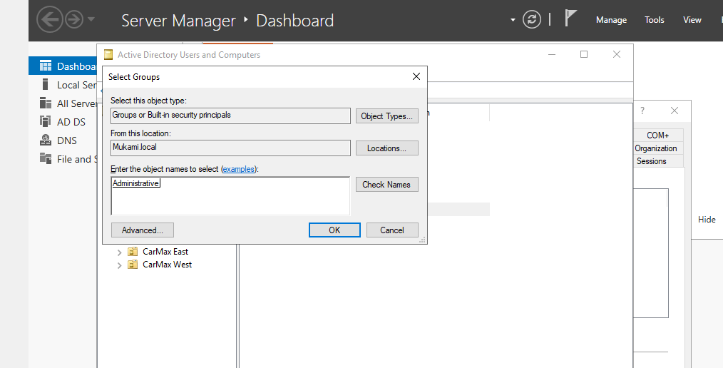

4.Assuming “One dummy” user in Mechanic Staff has gone on leave for one month, give a detailed description of how you will ensure **their user account is inactive and cannot be accessed by any other person during this one-month leave.** This is to ensure unauthorized users to do not use that account to access the organization system

ANSWER

Right click on the users account and clicking on disable. If the account is effectively disabled, there will be a downward arrow beside the user’s profile picture.

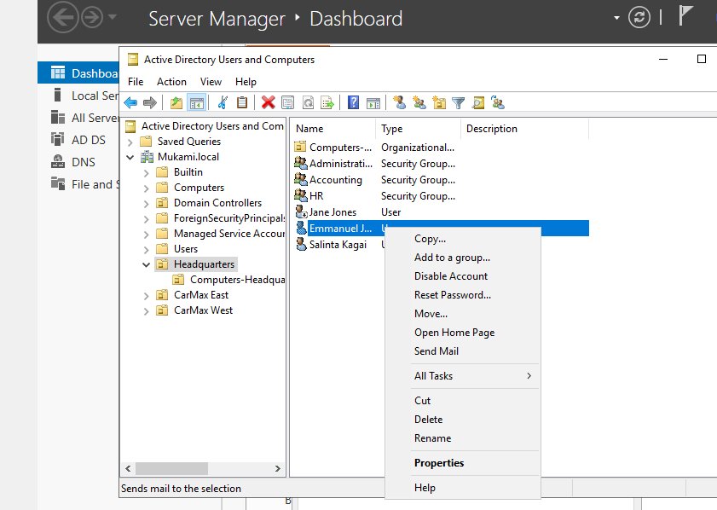

1. In accounting Dept, we want to maintain high notes of security especially to the computers. **Add a computer policy under Accounting Dept** to ensure all computers are locked or disabled after 3 minutes of inactivity. The user has to login once again when back.

Answer

The Accounting department is under the headquarters organizational unit therefore, I created a Group Policy Object GPO under headquarters called **Screen Time Out.** Then I went inside the GPO by right clicking on Screen Timeout, then edit. That took me to the group policy management editor. I further clicked on Computers Configuration-policies-windows settings- security-local policies-security Options-Interactive logon-Machine Inactivity.

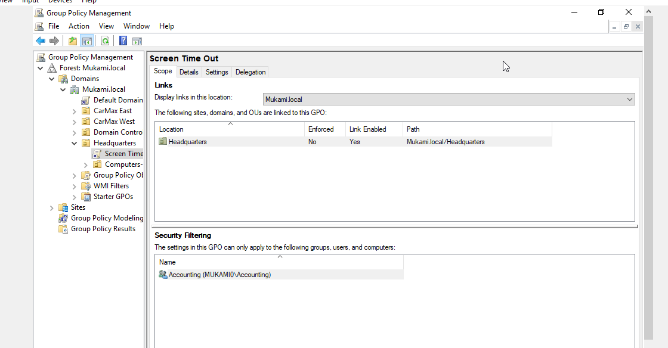

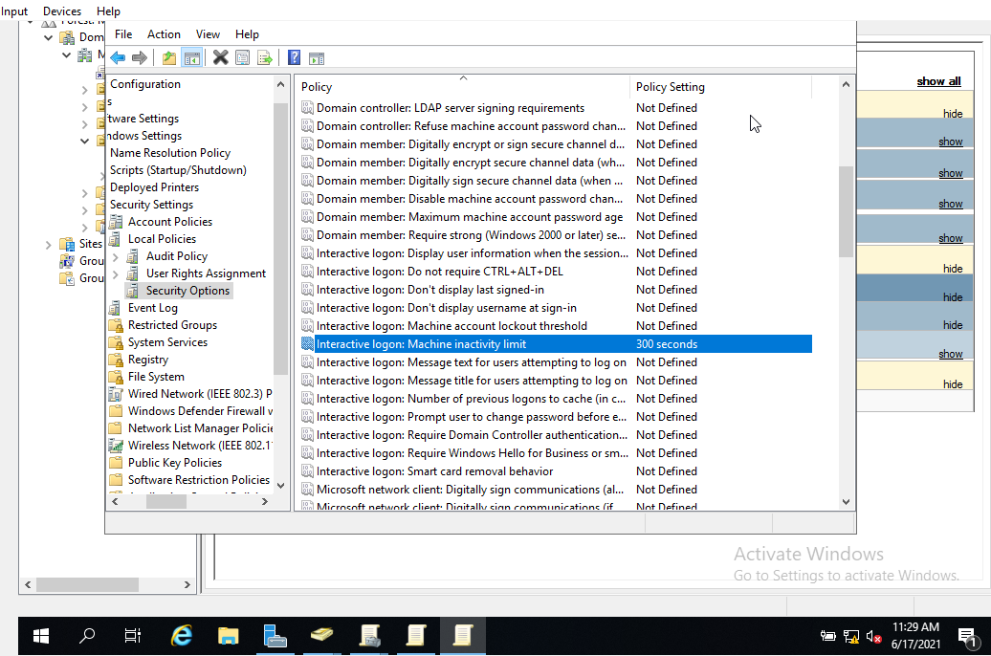

3 minutes=180seconds. I thus set the inactivity time to 180 seconds.

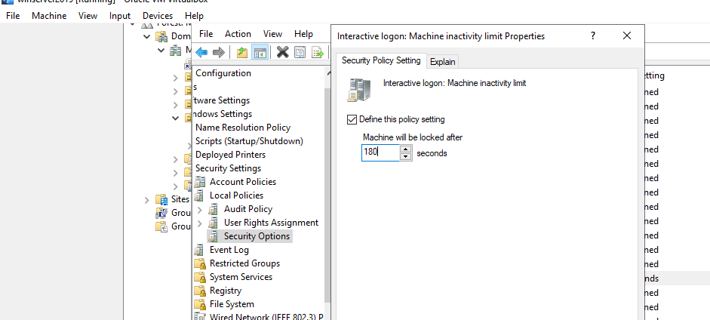

I then went into the Screen Timeout and under scope-security filtering, I added the accounting group. This mean the policy only applies to the accounting members and they have to log into the system if the screen stays idle for 3 minutes.

